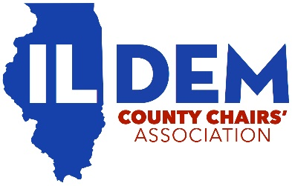
Illinois Democratic County Chairs’ Association
Proxy Authorization

STATE OF ILLINOIS )
) ss.
COUNT OF _________________________)

I, _______________________________________ (please print), Chair of the __________________________(please print) County Democratic Party, hereby appoint, __________________________________________ (please print), as my proxy to represent me at the IDCCA General Membership Meeting scheduled for February 20, 2021 at 12:00pm conducted virtually via Zoom, and to act in my stead, authorizing this person fully to do all things that I could or might do if personally present.
Specifically, I authorize ________________________________ (please print) to vote my one (1) vote to do every act whatsoever necessary or proper to be done in or upon all matters that may lawfully come before said meeting or any adjournment thereof.
Further, I hereby revoke any proxy or proxies previously given by me to any person or persons.

__________________________________________
Signature of County Chair

