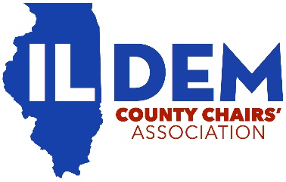
ILLINOIS DEMOCRATIC COUNTY CHAIRS’ ASSOCIATION
GENERAL MEMBERSHIP MEETING
SATURDAY FEBRUARY 20, 2021
CONDUCTED ONLINE VIA ZOOM
AGENDA
- Call to Order
- Pledge of Allegiance
- Guest Speakers
  - US Senator Tammy Duckworth
  - Scott Kennedy
  - MWRD Commissioner Josina Morita & Zach Koutsky
- President’s Report
- Secretary’s Report
  - Approval of minutes from August 1, 2020 General Membership Meeting
- Treasurer’s Report
  - Approval of Treasurer’s Report from August 2020 – February 2021
- Executive Director’s Report
- REV Project Update – County Party Resource Check In
- Virtual Training Series Update
- Party Builder Awards
- Committee Assignments
- 2020 Annual Report
- Adjourn

