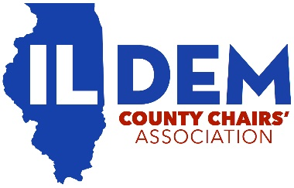
Illinois Democratic County Chairs’ Association
Proxy Authorization
STATE OF ILLINOIS )
) ss.
COUNTY OF ____________________________)

I, _______________________________________ (please print), Chair of the __________________________(please print) County Democratic Party, hereby appoint, __________________________________________ (please print), as my proxy to represent me at the IDCCA General Membership Meeting scheduled for May 16, 2020 at 12:00pm conducted online via Zoom and to act in my stead, authorizing this person fully to do all things that I could or might do if personally present.
I also authorize ______________________________ (please print) to vote my one (1) vote for all other acts whatsoever necessary or proper to be done in or upon all matters that may lawfully come before said meeting or any adjournment thereof.
Further, I hereby revoke any proxy or proxies previously given by me to any person or persons. This proxy authorization will only be in effect for the IDCCA General Membership Meeting called for May 16, 2020.

__________________________________________
Signature of County Chair

